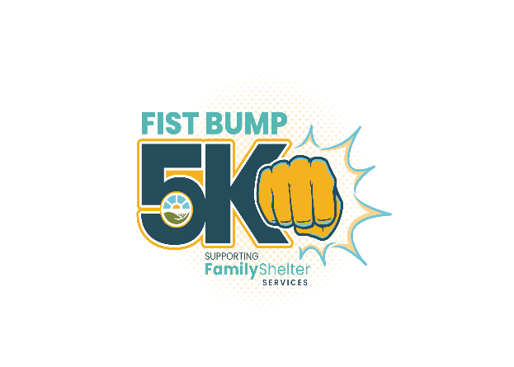SATURDAY APRIL 2, 2022 GREAT MEADOW – THE PLAINS
2nd Annual Fist Bump 5K
Fun Run & Walk to benefit
Family Shelter Services
GATES OPEN 7:30 AM RUN at 8:00 AM AWARDS AT 10:30AM INFLATABLES, FOOD & FUN UNTIL 11 AM
Fauquier Family Shelter Services—doing business as Family Shelter Services—is a private non-profit organization committed to serving individuals and families experiencing homelessness throughout the greater Piedmont region. We provide emergency shelter and transitional housing with comprehensive means and guidance to homeless families and individuals in our community. Our goal is to promote long-term stable housing, increase economic self-sufficiency and break the cycle of homelessness.
Together, we can advance our mission and help make it possible to end the cycle of homelessness!
$1,000 PLATINUM LEVEL SPONSORSHIP

- Event T-shirt recognition with corporate logo
- Event signage with corporate logo
- Company logo with website link to company’s website through Family Shelter Services
- Promotional recognition on social media
- Opportunity to include an insert or promotional items in race packets
- Up to 8 complimentary race registrations and T-shirts
$250 BRONZE LEVEL SPONSORHIP

- Event T-shirt recognition with corporate logo
- Event signage with corporate logo
- Online logo and direct access to your company’s website
- Social media recognition
- Up to 2 complementary race registrations and T-shirts

$500 SILVER LEVEL SPONSORSHIP

- Event t-shirt recognition with corporate logo
- Event signage with corporate logo
- Company logo with website link to company’s website through Family Shelter Services
- Social media recognition
- Up to 4 complementary race registrations and T-shirts

$750 GOLD LEVEL SPONSORSHIP

- Event T-shirt recognition with corporate logo
- Event signage with corporate logo
- Company logo with website link to company’s website through Family Shelter Services
- Social media recognition
- Opportunity to include an insert or promotional items in race packets
- Up to 6 complimentary race registrations and T-shirts

$100 PATRON LEVEL SPONSORSHIP

- Event T-shirt recognition with corporate logo
- Event signage with corporate logo
- Social media recognition
- 1 complementary race registration with T-shirt

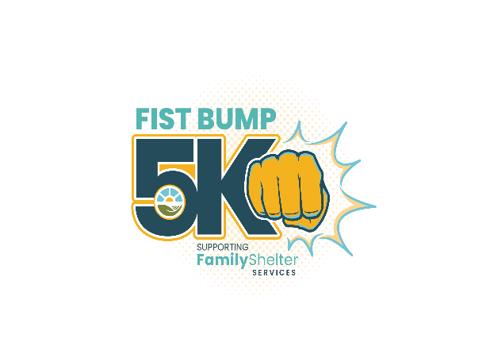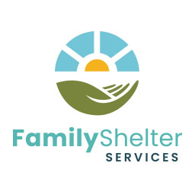
YES! WE WANT TO SPONSOR THIS EXCITING EVENT!

SPONSORSHIP LEVEL: CIRCLE ONE

Platinum - $1,000.00 Gold - $750.00 Silver - $500.00 Bronze - $250.00 Patron - $100.00

COMPANY NAME: ______________________________________________________________

CONTACT: ______________________________________________________________

MAILING ADDRESS: ______________________________________________________________

______________________________________________________________

EMAIL: ____________________________ PHONE: _________________________

I cannot sponsor the event but enclose a donation of $________________ to support the mission of Family Shelter Services.

PAYMENT OPTIONS:

EMAIL THIS FORM TO: gvent@fauquierfamilyshelter.org and

SUBMIT PAYMENT ON-LINE AT: familyshelterservices.org

OR MAIL THIS FORM WITH PAYMENT TO:
Family Shelter Services
PO Box 3599
Warrenton, Virginia 20188

SPONSORSHIP Commitment Deadline is March 20, 2022.

RAIN DATE APRIL 3, 2022
For more information, contact Gerry Vent at
gvent@fauquierfamilyshelter.org
540.680.2251

